Self adjusted deviation detection using MAD (median absolute deviation).

This algorithm is for detecting any important deviation in any metric using MAD and filtering based on historical pattern of the metric and its deviation.

Classic deviation detection algorithm usually look at a given time window of a metric time series and establish an upper and lower band for accepted deviations and assume any data point out of those band as a deviation. Band can be established using Bollinger Band or any of its variation.

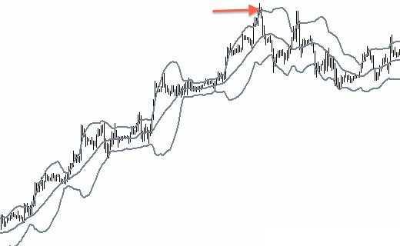

The issue with this kind of detection is that some metrics are very volatile by within a small window but still within its tolerated values and that will generate a lot of false positives. A better algorithm should detect accurately deviations that are worth alerting and eliminates false positive based on history and patterns.
-We have a way to measure the importance of the deviation in an absolute way
-We have to learn from the history of the metric on how the metric values trend.

This algorithm starts by computing the 90th percentile for a given window containing at least 30 data points. Then it derives a deviation time series that contains the distance between every original data point and the 90th percentile. We then compute the median of this new time series (MAD) and uses a multiplier x to detect alerts. Looking at the deviation time series and whenever the distance is greater than x times the MAD, it generates an alert if the value is above the historical 95th percentile of the metric.

95 %tile historical
90 %tile for window
d

- For a given window of n data points
  - Collect time series for window ts[]
  - Compute p90 for the window
  - Compute Deviation d(t)=|ts(t)-p90|
  - Median Absolute deviation MAD=Median(d)
  - Deviation multiplier dm(t)= d(t)/MAD
  - dmMax = 95th percentile of dm(t) computed on complete history of metric
- Alert when dm(t)>dmMax AND d(t)<p90

